HUNTER AND CENTRAL COAST REGION
REGIONAL PLANNING PANEL

Panel Reference | PPSHCC-93
DA Number | 8/2021/21907/1
LGA | Cessnock City Council
Proposed Development | Electricity Generating Works (5 Megawatt Solar Farm and Battery Storage)
Street Address | 1026 Lovedale Road, Allandale  Lot 201 DP 1099068
Applicant/Owner | Allandale Blue Metal Pty Ltd
Lodgement date | 5 October 2021
Submissions | 1 submission was received
Recommendation | That the application be approved
Regional Development Criteria | Clause 5, Schedule 7 of the SRD SEPP: Private infrastructure and community facilities over $5 million
List of all relevant s4.15 matters | - State Environmental Planning Policy (Resilience and Hazards) 2021;  - State Environmental Planning Policy (Planning Systems) 2021;  - State Environmental Planning Policy (Koala Habitat Protection) 2021;  - State Environmental Planning Policy (Transport and Infrastructure) 2021;  - Cessnock Local Environmental Plan 2011; and  Cessnock Development Control Plan 2010.
Enclosures | Appendix A – Development plans  Appendix B – Advice from Transport for NSW  Appendix C – Advice from Ausgrid
Report by | Sarah Hyatt, Principal Development Planner
Report date | 11 April 2022

RECOMMENDATION

That:
Development Application No. 8/2021/21907/1 proposing electricity generating works including 5 megawatt solar farm and battery storage, at 1026 Lovedale Road, Allandale, be determined by way of approval pursuant to Section 4.16 of the Environmental Planning and Assessment Act 1979, for the reasons contained in this report.

Summary of s4.15 matters  Have all recommendations in relation to relevant s4.15 matters been summarised in the Executive Summary of the assessment report? | Yes
Legislative clauses requiring consent authority satisfaction  Have relevant clauses in all applicable environmental planning instruments where the consent authority must be satisfied about a particular matter been listed and relevant recommendations summarized, in the Executive Summary of the assessment report? | Yes
Clause 4.6 Exceptions to development standards  If a written request for a contravention to a development standard (clause 4.6 of the LEP) has been received, has it been attached to the assessment report? | Not Applicable
Special Infrastructure Contributions  Does the DA require Special Infrastructure Contributions conditions (S94EF)? | No
Conditions  Have draft conditions been provided to the applicant for comment? | No

EXECUTIVE SUMMARY

- A development application has been submitted seeking approval for a 5 megawatt solar farm. The application also proposes works within a defined watercourse in order to achieve flood free access. These works will require separate approval from the Natural Resource Access Regulator with the application not lodged as integrated development.
In detail, the application proposes the following:

- Solar panels and array framing,
- Inverters and electrical switchgear,
- Transformer,
- Battery,
- Storage shed,
- Access road,
- Security fencing,
- Attachment to Ausgrid infrastructure, and
- Landscaping.

Following use of the site, the infrastructure will be decommissioned and the site rehabilitated.

- The subject application is referred to the Hunter and Central Coast Regional Planning Panel in accordance with Clauses 5, of Schedule 6 of State Environmental Planning Policy (Planning Systems) 2021. Specifically, the application proposes private infrastructure with a CIV over $5 million.

- The subject land is located south of Lovedale Road near the boundary between the Cessnock and Maitland Local Government Areas. Owned by Allandale Blue Metal Pty Ltd, the site forms part of a larger land holding operated as a quarry. Divided by the Hunter Expressway, approximately half the site is located to the north-east and half located to the south-west. Development proposed by this application is located on the portion of the site to the north-east of the expressway, while the south-western portion will continue to be used for grazing purposes and also contains the quarry access road. Access to the north-east portion of the site is direct from Lovedale Road.

- The development is consistent with Cessnock Local Environmental Plan 2011 and is a permitted form of development in the RU2 Rural Landscape zones. State Environmental Planning Policy (Transport and Infrastructure) 2021, Clause 2.36 (9) further permits solar systems on any land.

- The proposed development was exhibited in accordance with the provisions of Council’s Community Participation Plan. The application was exhibited between the 22 October and 5 November 2021. In response, one (1) submission was received.

- The applicant has submitted additional information in response to Councils preliminary assessment.

- The proposal has been assessed against the relevant matters for consideration under Section 4.15 of the Environmental Planning and Assessment Act 1979. The proposed development is considered to be suitable and is recommended for approval subject to conditions.

ZONING MAP

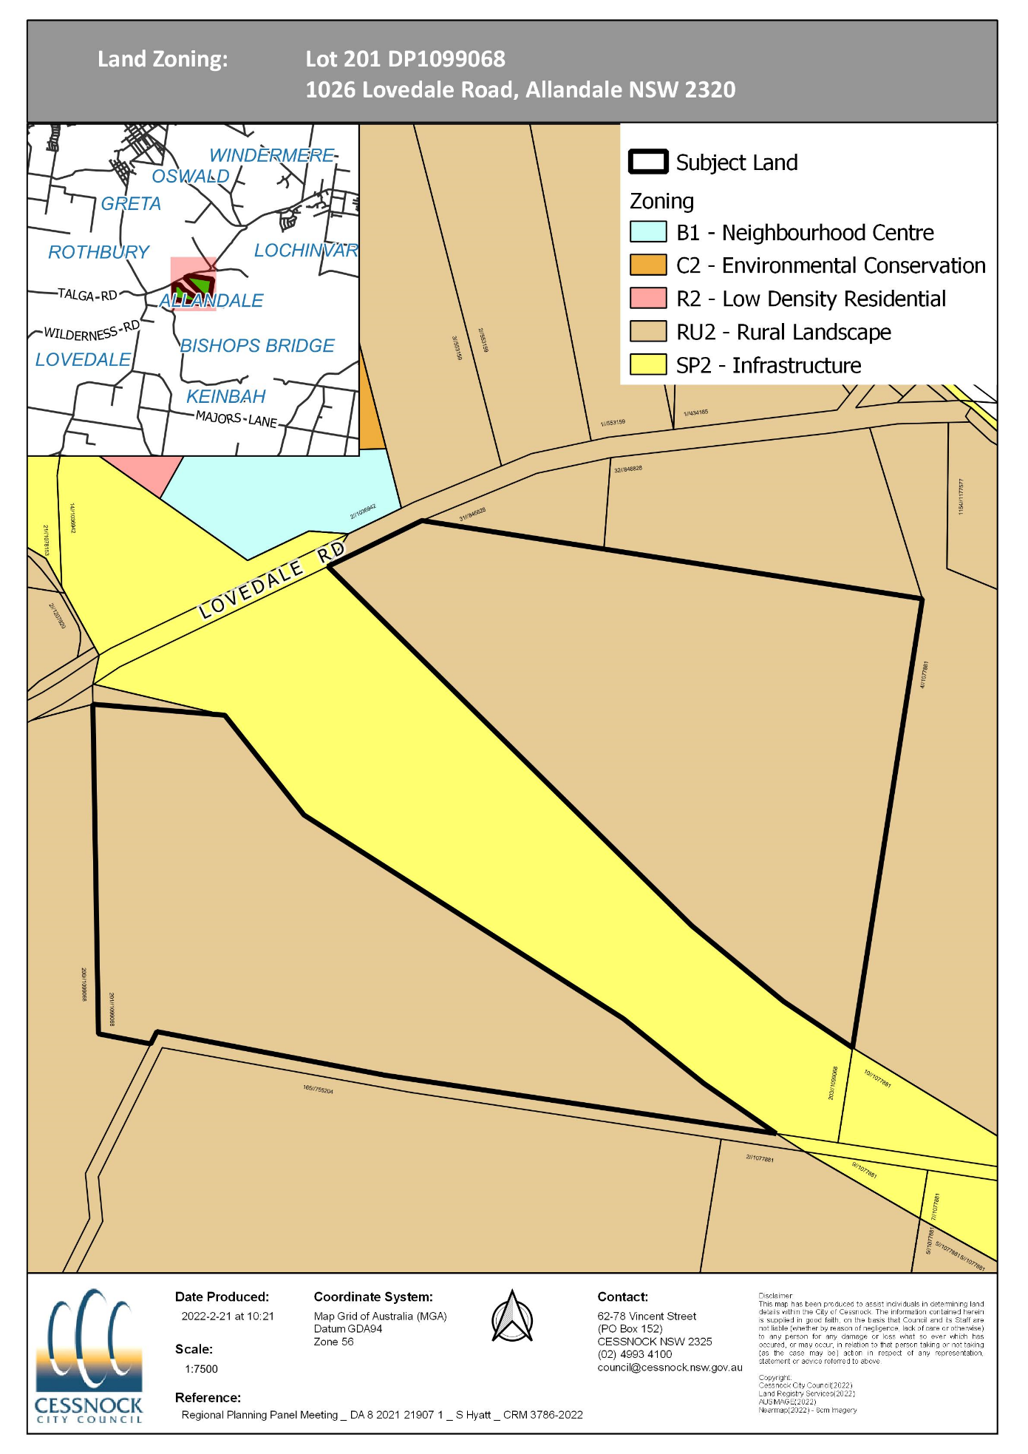

SITE DESCRIPTION

The subject site is commonly known as 1026 Lovedale Road Allandale, and is legally described as Lot 201 DP 1099068.

The subject land is located south of Lovedale Road near the boundary between the Cessnock and Maitland Local Government Areas. Owned by Allandale Blue Metal Pty Ltd, the site forms part of a larger land holding which is operated as a quarry. Divided by the Hunter Expressway, approximately half the site is located to the north-east and half located to the south-west. Development proposed by this application is located on the portion of the site to the north-east of the expressway, while the south-western portion will continue to be used for grazing and contains the quarry access. Access to the north-east portion of the site is direct from Lovedale Road.

Most of the land is slightly undulating, traversed by a water course through the centre of the site.

The site consists of grassy paddocks used for low-scale grazing purposes with scattered trees. A dilapidated dwelling and outbuilding is located to the north western corner adjacent to Lovedale Road. Vegetation on the site consists of fragmented patches of Lower Hunter Spotted Gum Ironbark Forest and Lower Hunter Redgum Forest, with a significant portion of the site existing as cleared pastoral lands. The subject land is also identified as being bushfire prone.

AERIAL

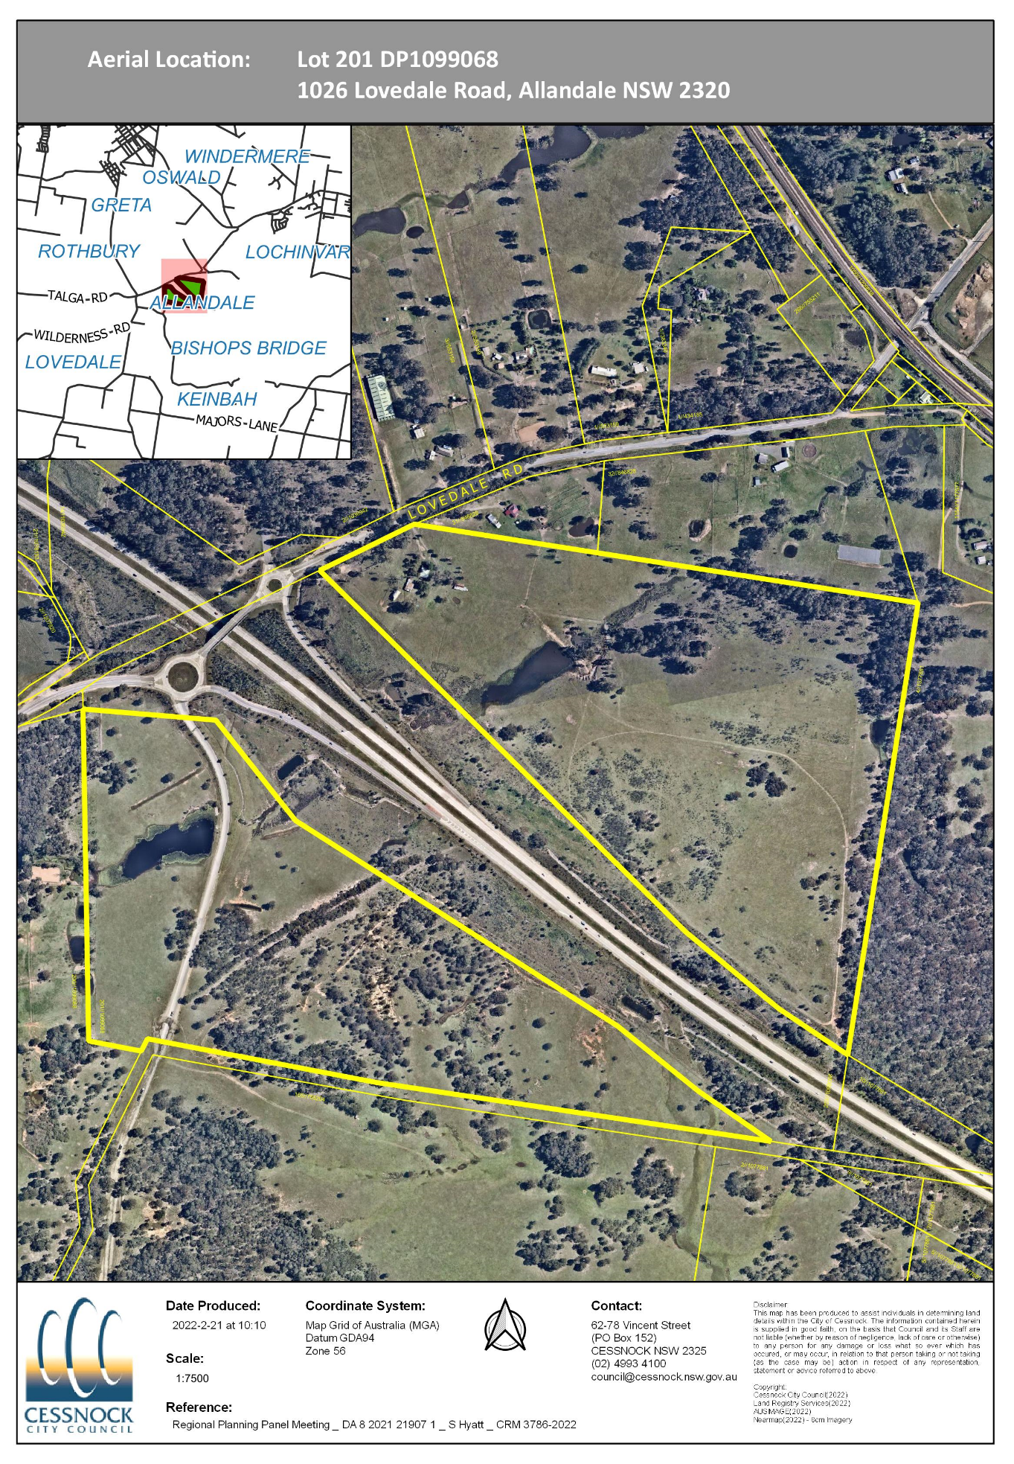

LOCALITY

The subject land is located south of Lovedale Road near the boundary between the Cessnock and Maitland Local Government Areas.

The Hunter Expressway dissects the land into a southern portion containing the quarry access road, and a northern portion which is proposed to contain the solar farm. Located at the entrance to the Lovedale portion of the Vineyards District, development in the surrounding locality consists of grazing land, single dwellings and viticultural land uses.

To the north of the subject land is the heritage listed Greta Migrant Camp, listed in the Cessnock Local Environmental Plan 2011 as an item of local significance.

LOCALITY MAP

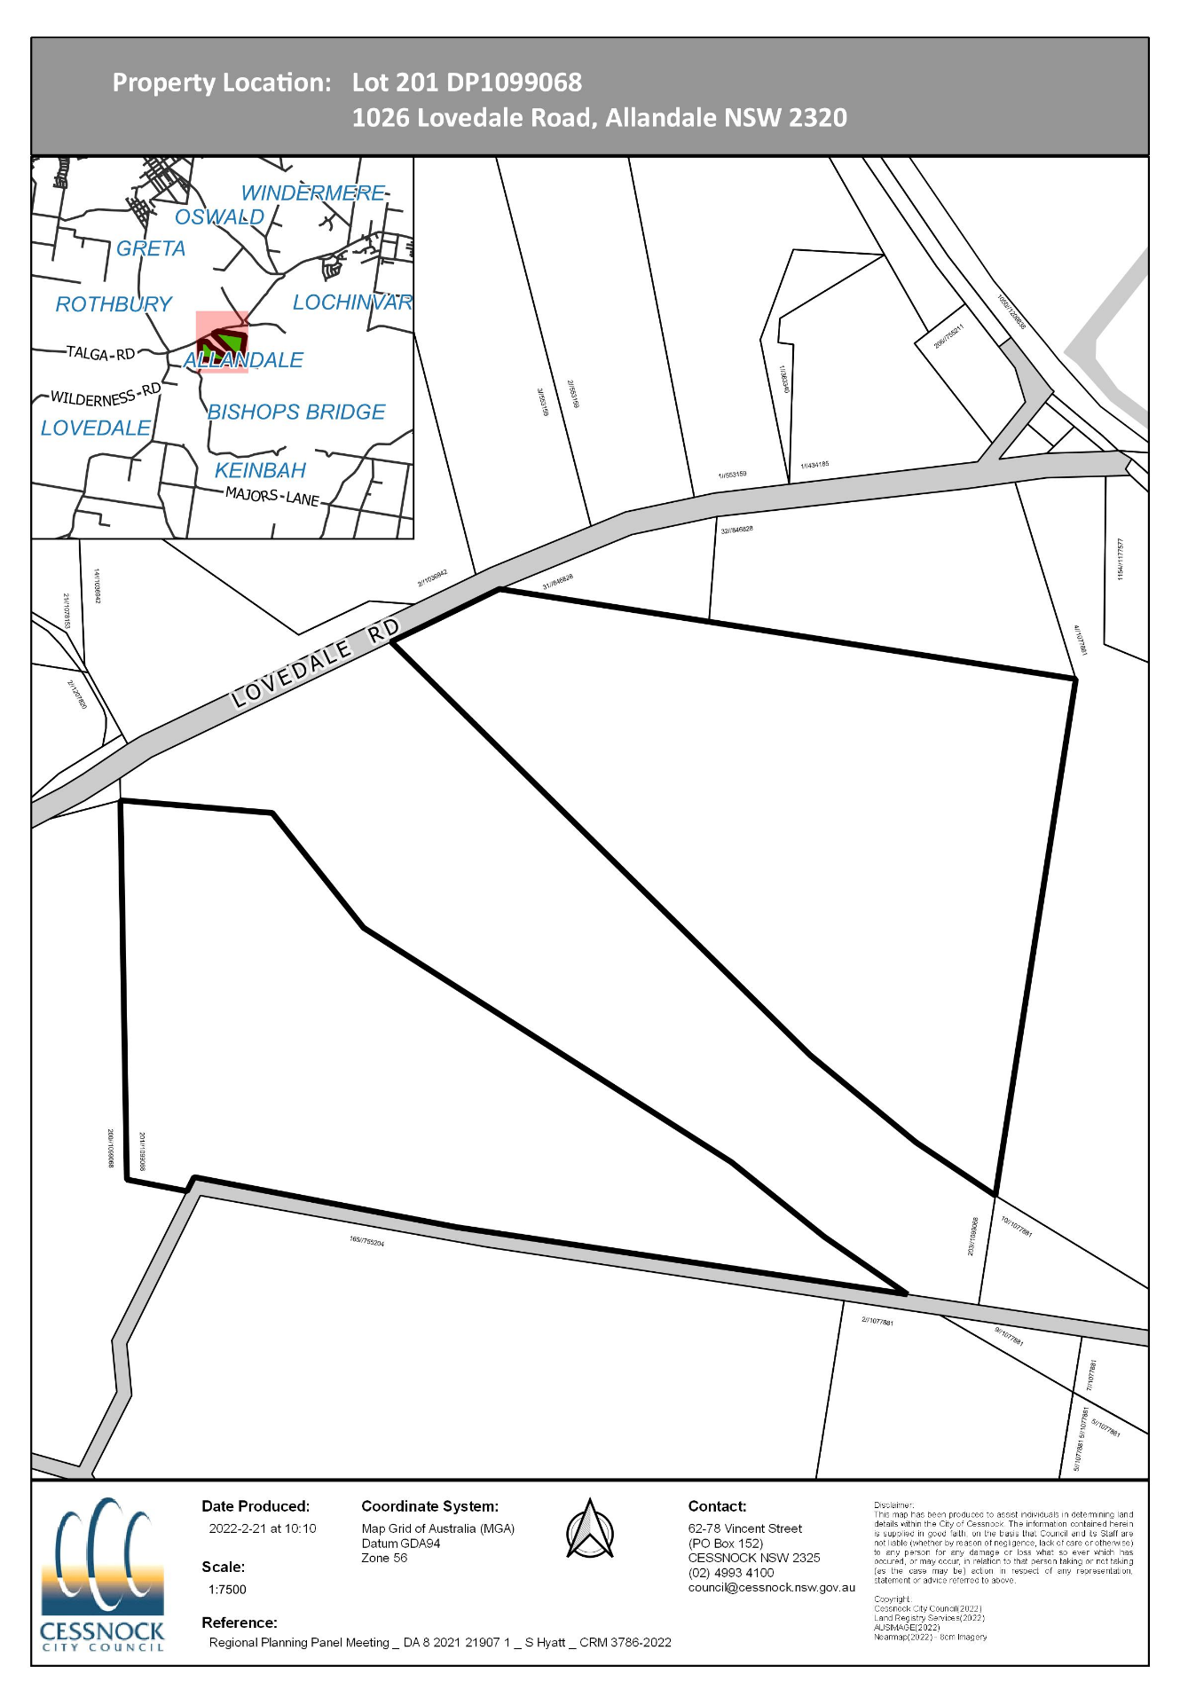
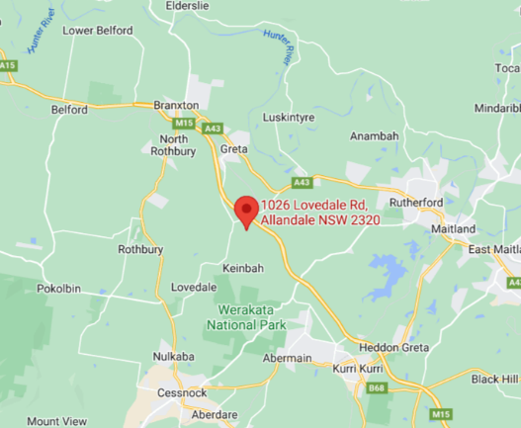
HISTORY OF DEVELOPMENT APPLICATION

The history of the subject development application is summarised in the following table:

Date | Action
5 October 2021 | Development Application lodged with Council.
8 October 2021 | Internal referrals initiated and external referral to Ausgrid.
13 October 2021 | Referral response received from Ausgrid.
19 October 2021 | Initial request for additional information to applicant to confirm use of existing buildings; area plan with dimensions of solar farm including details of panels; updated site plan confirming distances to boundaries; and plans of proposed shed.
22 October 2021 | Public exhibition period commences.
27 October 2021 | Response received from applicant.
4 November 2021 | Referral to TfNSW.
5 November 2021 | Public exhibition period concludes, one submission received.
11 November 2021 | Regional Planning Panel briefing.
15 November 2021 | Additional information requested in response to panel briefing including:  - Decommissioning and site rehabilitation report,  - Visual impact assessment,  - Detailed site plans, including a panel layout plan,  - Details including floor plans and elevation of proposed awning, and  - A minor flood assessment in accordance with Chapter C.9 of the Cessnock Development Control Plan 2010.
18 November 2021 | Referral response received from TfNSW.
11 March 2022 | Additional information received and referred for comment.
11 April 2022 | Assessment finalised and uploaded to Regional Planning Panel for determination.

SITE HISTORY

Historical Use/s of the Site

The subject land has been historically used for grazing, and forms part of a larger land holding owned by Allandale Blue Metal which provides aggregate materials to the construction industry. Divided by the Hunter Expressway, the southern portion of the site contains the access road for the quarry while the northern portion contains a dilapidated dwelling and a series of outbuildings.

Other Development Applications

There are no contemporary development applications lodged over the subject land.

DETAILS OF THE PROPOSED DEVELOPMENT

Summary of Proposal

Development Application No. 8/2021/21907/1 seeks approval for a 5 megawatt solar farm. Specifically, the solar farm includes the following components:
- Solar panels and array framing,
- Inverters, electrical switchgear,
- Transformer,
- Battery,
- Storage shed,
- Access road,
- Security fence,
- Attachment to Ausgrid infrastructure, and
- Landscaping
The proposed solar array will occupy approximately 4.4ha of the 59.42 ha site. The proposed solar array will be constructed using a lightweight structure known as PEG shown in Figure 1 below. Unlike typical solar arrays, the light-weight system is able to be installed with no large gaps reducing inter-row shading. Rows of panels will be constructed end-to-end, titled at 8⁰ to the east/west with rows running north-south and will be sited approximately 1m above ground level. Ground below the solar array will be covered with plastic sheeting and lined with gravel to minimise ongoing maintenance.
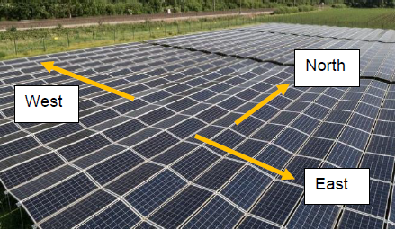
Figure 1: Typical PEG array arrangement
Access to the site is from Lovedale Road. Works are proposed within the watercourse running through the site which will include installation of a 1800mm x 1800mm box culvert. The application has not been lodged as integrated development, therefore, appropriate approval/s from the Natural Resource Access Regulator will be required to be obtained separately to this application.
Maintenance will occur at regular scheduled intervals typically Monday to Friday 7:00am to 6:00pm, and Saturday 8:00am to 1:00pm. Emergency maintenance may occur outside of these times as required.
Once the life of the development has expired, the site is to be decommissioned as follows:
- Disconnection from Ausgrid infrastructure,
- Removal of the following components to be either reused, salvaged for another project or recycled:
  - PV modules;
  - PV racking system;
  - Above and belowground electrical cables;
  - Inverters, transformers and switchgear;
  - Inverter pads;
  - Transformer pads; and
  - Concrete foundations.
- Perimeter fencing and storage shed to be either removed or repurposed and reused by the owner,
- Any hazardous and non-hazardous materials will be removed from the site, and
- Below ground infrastructure located below 500mm will be left in-situ.
Following removal of the infrastructure, rehabilitation will be undertaken consisting of the following:
- Backfilling of trenches and excavations,
- Topsoiling, and
- Reseeding of the disturbed area with native grass.
In accordance with the Decommissioning and Site Rehabilitation Plan, the remediated area is proposed to be monitored for 12 months following decommissioning.
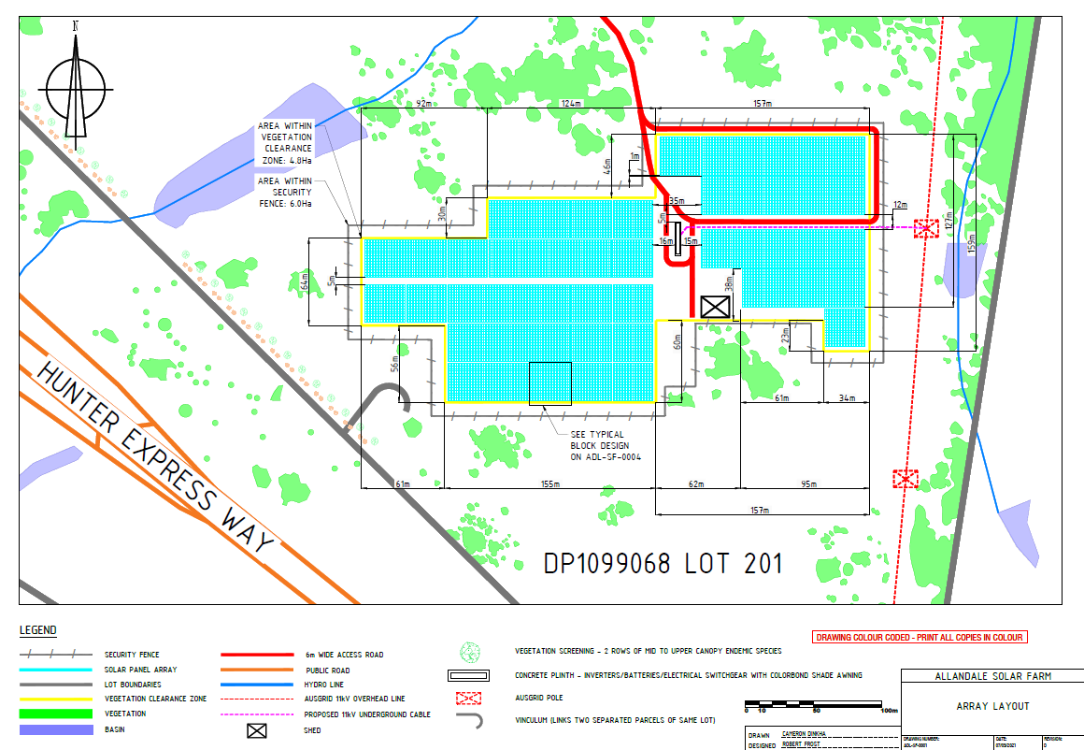

Figure 2: Plan of proposed solar array arrangement
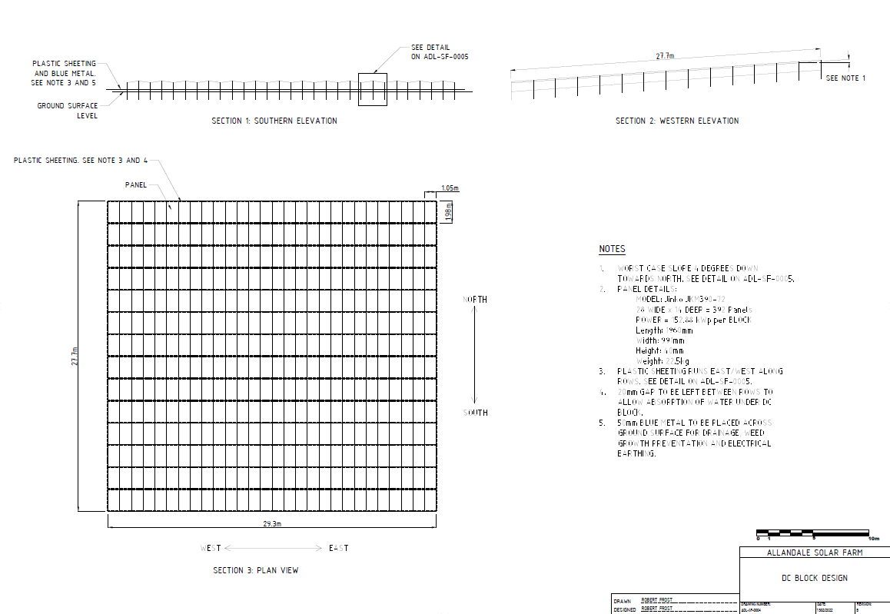

Figure 3: Plan of solar panel arrangement

PRELIMINARY MATTERS

Below is a discussion of the pertinent matters in respect of this application:

Visual Impact

The potential visual impact of the proposed development has been considered from the following vantage points:

- Viewpoints 1 and 2 looking south towards the development from neighbouring property to the north,
- Viewpoint 3 at the entrance of the site on Lovedale Road looking east,
- Viewpoints 4, 5, 6, 7 and 8 looking north towards the development from the Hunter Expressway entrance ramp, and
- Viewpoints 9 and 10 looking north towards the development site from the Hunter Expressway.

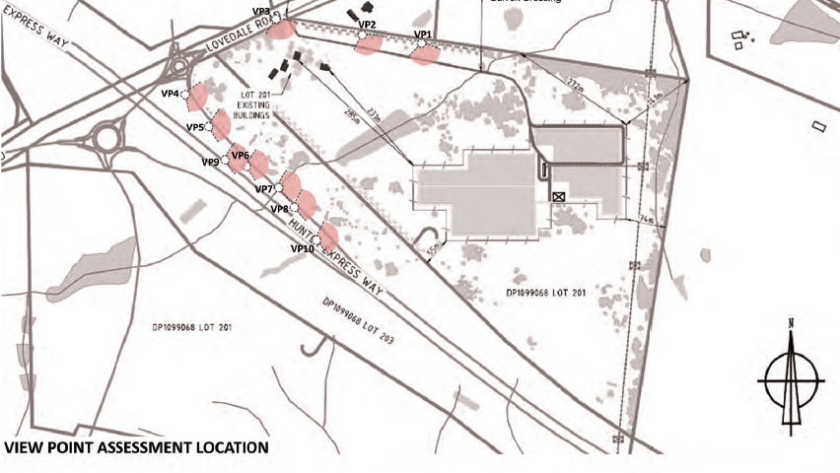
Figure 4: Visual Impact Assessment – vantage point

Visual impact has been determined based on visual sensitivity; measured by land use and distance and visual effect; measured by size and bulk, colour/reflection and visibility. This methodology has been applied to each of the viewpoints identified in Figure 4 above. Viewpoints 1 and 2 have been determined to be of moderate impact based on an assessment of the visual sensitivity and visual effect. These vantages are shown below. All other vantages are considered to be low to nil impact.

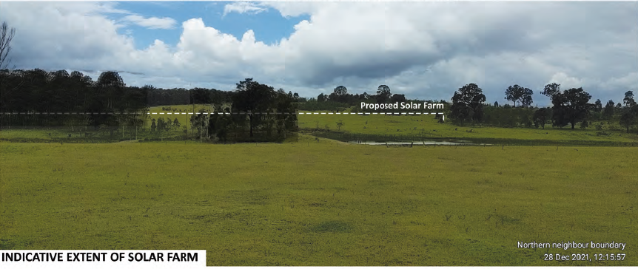

Figure 5: Vantage Point 1 from Visual Impact Assessment

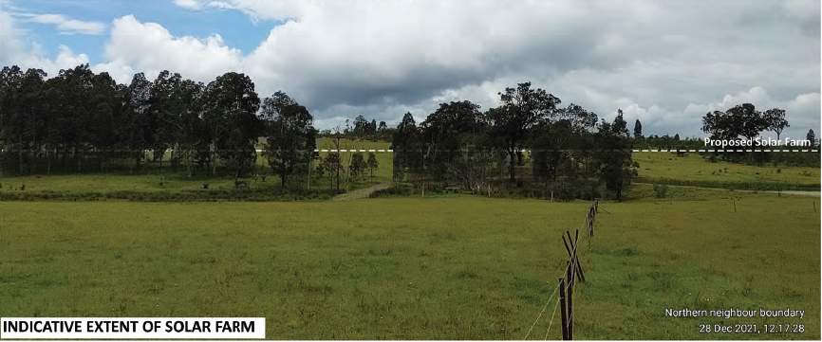
Figure 6: Vantage Point 2 from Visual Impact Assessment

The vistas above demonstrate that the development will be visible from the neighbouring property to the north, which is considered to result in a moderate impact. Located approximately 320m from the neighbouring property, potential for the development to impact on the existing dwelling is low while the separation distance between the dwelling and this development is considered to result in a moderate impact. As demonstrated by this application, the array will sit approximately 1m above natural ground level which results in a low impact in terms of bulk and scale. The visual impact assessment identified the potential for reflectivity to be experienced from these vantage points, with the impact considered to be moderate.

In order to reduce the visual impact of the development, additional landscaping is proposed along the northern boundary and throughout the site. It is considered that with the addition of further landscaping, and considering the separation distance between development on the adjoining lot and this development, the overall visual impact is not considered to be significant nor result in any significant impact in terms of the ongoing use of the neighbouring property or view loss.

Glimpses of the development will be visible from the entrance ramp to the Hunter Expressway; viewpoints 4 to 8. Based on a speed limit of 80km per hour, increasing to 110km per hour; these glimpses are not considered to result in any significant distraction nor interference in concentration of passing motorists. With the addition of further landscaping, opportunities to see the development from the entrance ramp will be further reduced. An example of this vista is provided below:

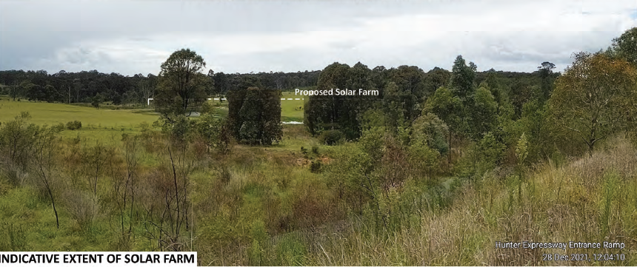
Figure 7: Vantage Point 6 from Visual Impact Assessment

The visual impact assessment demonstrates that the development will not be visible from the Hunter Expressway, with the level of the road sitting below the level of the entrance ramp, thereby screening the development from view as demonstrated in the vista below.

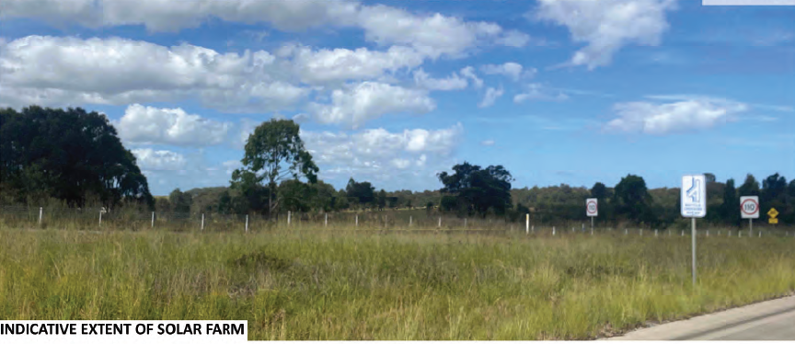
Figure 8: Vantage Point 10 from Visual Impact Assessment

In this regard, the visual impact of the proposed development is not considered to be significant.

ASSESSMENT

ENVIRONMENTAL PLANNING AND ASSESSMENT ACT 1979

Section 1.7

Section 1.7 of the Environmental Planning and Assessment Act 1979, prescribes as follows:

‘This Act has effect subject to the provisions of Part 7 of the Biodiversity Conservation Act 2016 (BC Act) and Part 7A of the Fisheries Management Act 1994 that relate to the operation of this Act in connection with the terrestrial and aquatic environment’.

Biodiversity Conservation Act 2016

A Biodiversity Development Assessment Report (BDAR) prepared by Umwelt dated September 2021, was submitted in conjunction with the application. Council’s Ecologist has reviewed the BDAR, noting the following:

- One Plant Type Community (PCT) was found to occur within the proposed development footprint; PCT 1601 – Spotted Gum – Narrow-leaved Ironbark – Red Ironbark Shrub – Grass Open Forest of the Central and Lower Hunter Derived Native Grassland. Four individual specimens of the critically endangered flora species, Slaty Red Gum (Eucalyptus glaucina), were recorded outside of the development footprint.
- The Biodiversity Offset Scheme (BOS) has been triggered, as the proposed development exceeds the clearing threshold of 1 ha, based on a minimum lot size of 40 ha. The vegetation within the development footprint was allocated a Vegetation Integrity Score (VIS) of 7.1. Given that the VIS is less than 15, offsetting under the BOS is not required and no ecosystem credits have been generated as a result of the proposal.
- The development footprint and internal access road have been located in areas of the lot where the potential ecological impact is considered low.
- The proposed development will have a relatively minimal impact on the native flora and fauna habitat present within the locality.

The application is considered to be acceptable from a biodiversity perspective.

ENVIRONMENTAL PLANNING AND ASSESSMENT ACT 1979

Section 4.15(1) Evaluation

In determining the Development Application, the consent authority is to take into consideration any relevant matters prescribed within s.4.15 of the Environmental Planning and Assessment Act 1979, as are of relevance to the development the subject of the development application:

4.15(1)(a)(i) The Provisions of any Environmental Planning Instrument

The Environmental Planning Instruments that relate to the proposed development are:

- State Environmental Planning Policy (Planning Systems) 2021
- State Environmental Planning Policy (Transport and Infrastructure) 2021
- State Environmental Planning Policy (Koala Habitat Protection) 2021
- State Environmental Planning Policy (Resilience and Hazards) 2021
- Cessnock Local Environmental Plan 2011

An assessment of the proposed development under the Environmental Planning Instruments (EPIs) is provided below.

1. STATE ENVIRONMENTAL PLANNING POLICY (PLANNING SYSTEMS) 2011

As outlined previously, the development is a type of development that is identified as being ‘regionally significant’ in accordance with Clause 5 of Schedule 6 of State Environmental Planning Policy (State and Regional Development) 2021.

2. STATE ENVIRONMENTAL PLANNING POLICY (TRANSPORT AND INFRASTRUCTURE) 2021

Division 4 – Electricity Generating Works or Solar Energy Systems applies to this proposal. The proposed solar farm is not exempt development under this division.

In accordance with Clause 2.36 (9), solar energy systems (defined in this instance as a photovoltaic electricity generating system), are permitted with consent by any person on any land. There are no restrictions on determining the development consent under this SEPP. The proposal complies with the SEPP as development consent has been sought.

3. STATE ENVIRONMENTAL PLANNING POLICY (KOALA HABITAT PROTECTION) 2021

The aim of the policy is to encourage the conservation and management of areas of natural vegetation that provide habitat for koalas to support a permanent free-living population over their present range and reverse the current trend of koala population decline. This policy is applicable to the Cessnock LGA. The site was not considered to contain highly suitable habitat. Therefore the land was not considered to be core koala habitat and no further provisions of the Koala Habitat Protection SEPP apply.

4. STATE ENVIRONMENTAL PLANNING POLICY (RESILIENCE AND HAZARDS) 2021

The intent of this policy is to promote the remediation of contaminated land for the purpose of reducing the risk of harm to human health or any other aspect of the environment.

Clause 4.6(1) requires that consent not be granted until Council has considered whether the land is contaminated. If the land is contaminated, the Council needs to be satisfied that the land is suitable in its contaminated state (or will be suitable, after remediation) for the purpose for which the development is proposed to be carried out.

The subject site has historically been used for grazing.

No evidence of contamination was observed during inspection of the site. As there is no historical evidence of the site being previously used for a purpose which would result in the land being contaminated, further testing of the site in respect of contamination is not warranted in this instance.

5. CESSNOCK LOCAL ENVIRONMENTAL PLAN 2011

5.1 Permissibility

The site is zoned RU2 Rural Landscape under the Cessnock Local Environmental Plan 2011. Development proposed by this application is characterised as ‘electricity generating works’ which is defined as follows:

electricity generating works means a building or place used for the purpose of—
(a) making or generating electricity, or
(b) electricity storage.

Electricity generating works are permissible with consent in the zone. A solar energy system is not separately defined in the CLEP 2011. Solar energy systems can be further characterised via a notation in the Land Use Table of the CLEP 2011 (below):

“A type of development referred to in the Land Use Table is a reference to that type of development only to the extent it is not regulated by an applicable State environmental planning policy. The following State environmental planning policies in particular may be relevant to development on land to which this Plan applies: …

State Environmental Planning Policy (Infrastructure) 2007—relating to infrastructure facilities such as those that comprise, or are for, air transport, correction, education, electricity generating works and solar energy systems, health services, ports, railways, roads, waste management and water supply systems.”

State Environmental Planning Policy (Transport and Infrastructure) 2021 is referred to for clarification on permissibility. As per Clause 2.36(9) of this SEPP, a solar energy system “may be carried out by any person with consent on any land”. Effectively, a solar energy system is permitted with consent on land zoned RU2.

The other aspects of the development, comprising access road and landscaping are all considered ancillary to the primary purpose.

5.2 Zone Objectives

The objectives of the RU2 Rural Landscape zone are as follows:

- To encourage sustainable primary industry production by maintaining and enhancing the natural resource base.
- To maintain the rural landscape character of the land.
- To provide for a range of compatible land uses, including extensive agriculture.
- To enable other forms of development that are associated with rural activity and require an isolated location or support tourism and recreation.
- To ensure that the type and intensity of development is appropriate in relation to the rural capability and suitability of the land, the preservation of the agricultural, mineral and extractive production potential of the land, the rural environment (including scenic resources) and the costs of providing services and amenities.
- To maintain and enhance the scenic character of the land.
- To ensure that development does not create unreasonable or uneconomic demands for the provision or extension of services.
- To minimise the visual impact of vegetation clearing in order to be consistent with the rural character of the locality.
- To minimise disturbance to the landscape from development through clearing, earthworks, access roads and construction of buildings.
- To ensure development does not intrude into the skyline when viewed from a road or other public place.

The proposed development is consistent with the objectives of the zone, providing a landuse that is not inconsistent with development in the surrounding area and is well placed to connect into the existing infrastructure. The development will not restrict the use of the site for another purpose either now or into the future. Proposed infrastructure is able to be removed and the site returned to a pre-development state.

5.3 Relevant Clauses

5.3.1 Clause 2.3 Zone Objectives and Land Use Table

This clause outlines how the land use table within the CLEP specifies a zone, the objectives for the zone, development that may be carried out with or without development consent, and prohibited development. The clause also requires that the consent authority must have regard to the objectives for development in a zone when determining an application. The land use zone and permissibility of the proposed use has been raised previously within this report. Accordingly, the provisions of this clause are satisfied.

5.3.2 Clause 7.2 Earthworks

Clause 7.2 seeks to ensure that any earthworks do not result in an adverse impact on the environment, neighbouring properties or heritage items. Earthworks proposed as part of this development are considered to be minor and will not result in any significant impact on the land, surrounding properties or the environment.

5.3.3 Clause 7.14 Essential Services

Clause 7.14 aims to ensure that essential services are available or that adequate provision has been made to facilitate development within the RU2 zone. The proposal relies upon the ability to connect into existing Ausgrid infrastructure. A referral was sent to Ausgrid for comment, with recommended conditions of approval provided. Accordingly, the proposed development is consistent with the requirements of this clause.

5.3.4 Clause 7.15 Groundwater Vulnerability

This clause aims to ensure that development on land zoned RU2 does not impact upon the groundwater system by means of depletion or contamination. In accordance with the requirements of this clause, the proposed development will not result in the contamination of the ground water system as a result of the use of the land. The overall cumulative impact of the development will not have a significant impact upon groundwater quality or supply. Development proposed is considered to be consistent with the requirements of this clause.

4.15(1)(a)(ii) The provisions of any proposed instrument that is or has been the subject of public consultation under this Act and that has been notified to the consent authority (unless the Planning Secretary has notified the consent authority that the making of the proposed instrument has been deferred indefinitely or has not been approved

Environmental Planning and Assessment Regulation 2021

It is noted that the Environmental Planning and Assessment Regulation 2021 came into force on 1 March 2022.

Notwithstanding the commencement of the Environmental Planning and Assessment Regulation 2021, Schedule 6 prescribes relevant savings, transitional and other provisions. In particular, the following savings provision is relevant to consideration of this application:

3 Development applications and applications for complying development certificates
The 2000 Regulation continues to apply instead of this Regulation to a development application and an application for a complying development made but not finally determined before 1 March 2022.

It is noted that the subject application was lodged prior to 1 March 2022. Therefore, the provisions of the Environmental Planning and Assessment Regulation 2000 continue to apply, and the application has been assessed with consideration given to these provisions.

4.15(1)(a)(iii) The Provisions of any Development Control Plan

Cessnock Development Control Plan 2010

The following is an assessment of the proposal’s compliance with the numerical standards in the DCP:

Cessnock Development Control Plan
Part C: General Guidelines
Chapter – C.1 Parking and Access | Complies? | Comment
1.2 Car Parking Standard  1.4.1 Access | Yes | Onsite car parking is able to be provided in accordance with the DCP. Councils Development Engineer has considered the proposed access arrangements which are deemed to be satisfactory. The applicant will be required to gain separate approval from the Natural Resources Access Regulator for works required within the watercourse.
Chapter – C.3: Contaminated Lands | Complies? | Comment
Development Applications for, or which include, site remediation works shall be accompanied by a RAP in accordance with the provisions of SEPP 55 - Remediation of Land. | Yes | There is no evidence to suggest that the site has previously been used for a purpose that would have resulted in the land being unfit for the use proposed. The site is considered to be suitable to accommodate the development.
Chapter – C.5 Waste Management and Minimisation | Complies? | Comment
5.7.1 Potential for Waste Minimisation | Yes | Minimal waste will be generated during construction and ongoing operation. All waste shall be removed from the site and disposed of at an appropriate facility.
Chapter – C.9 Development on flood Prone land | Complies? | Comment
Development is considered to be critical infrastructure | Yes | The site is affected by flooding during the 1% AEP event from a 2nd order watercourse which flows north to south. As per DCP Chapter C9, this development is considered critical infrastructure. The proposed infrastructure is outside the floodplain; however, a minor flood study providing details on the management of floods up to and including the PMF, was required to be submitted. A hydrogeological report with proposed flood mitigation measures to ensure a flood free access was submitted by the applicant. The access surface level is proposed to be at 300mm freeboard above the calculated 1% head water. The access driveway is proposed at 93.09m AHD. Accordingly, the development is consistent with the provisions of the DCP.

4.15(1)(a)(iiia) The provision of any Planning Agreement that has been entered into under Section 7.4, or any draft Planning Agreement that a developer has offered to enter into under Section 7.4

No such agreement has been proposed as part of this application.

4.15(1)(a)(iv) The provisions of the regulations
There are no matters prescribed by the Environmental Planning & Assessment Regulation 2000 relevant to this application.

4.15(1)(b) The likely impacts of that development, including environmental impacts on both the natural and built environments, and social and economic impacts on the locality

As demonstrated by this assessment, the proposed development is unlikely to have a significant impact on the natural and built environment, and social and economic conditions within the locality.

4.15(1)(c) The suitability of the site for the development

As demonstrated by this assessment, the site is considered suitable for the development. Site constraints have been considered in the assessment of this application, and it is considered that there are no known constraints that warrant refusal of the application.

4.15(1)(d) Any submissions made in accordance with this Act or the Regulations

The application was publicly exhibited in accordance with the Cessnock Community Participation Plan. The application was exhibited between the 22 October and 5 November 2021. One (1) submission was received in objection to the proposed development.

The following table outlines the issues raised in the submissions lodged with Council, along with a response to each matter:

Issue/s | Comment/s
Property value
Impact on property value | Impact on property value is not a matter for consideration under Section 4.15 of the EP&A Act.
View loss
Impact on scenic quality and views | A visual impact assessment was submitted in support of the application. The findings of the assessment are addressed in this report. In summary, while the proposed development is considered to have a nil to moderate impact on the existing visual landscape, it is considered that the siting of the development in conjunction with additional landscaping will reduce the visual impact of the development when viewed from adjoining land and public places.  Overall, the development is not considered to have a significant impact on the scenic quality or visual amenity of the area.

4.15(1)(e) The public interest

The public interest is served through the detailed assessment of this Development Application under the Environmental Planning and Assessment Act, 1979, Environmental Planning and Assessment Regulation 2000, Environmental Planning Instruments and Council policies. Based on the above assessment, it is considered that the proposed development is in the public interest.

Section 4.46 (Integrated Development)

The proposed development has not been lodged as integrated development. Mitigation works are proposed within 40m of the watercourse running through the property to achieve flood free access. The applicant will be required to seek the relevant approvals from the Natural Resource Access Regulator separate to this application.

SECTION 7.12 CONTRIBUTIONS

The ‘Cessnock Section 7.12 Levy Contributions Plan 2017’, applies to the application. Development contributions have been calculated on a development cost of $7,815,000.00.

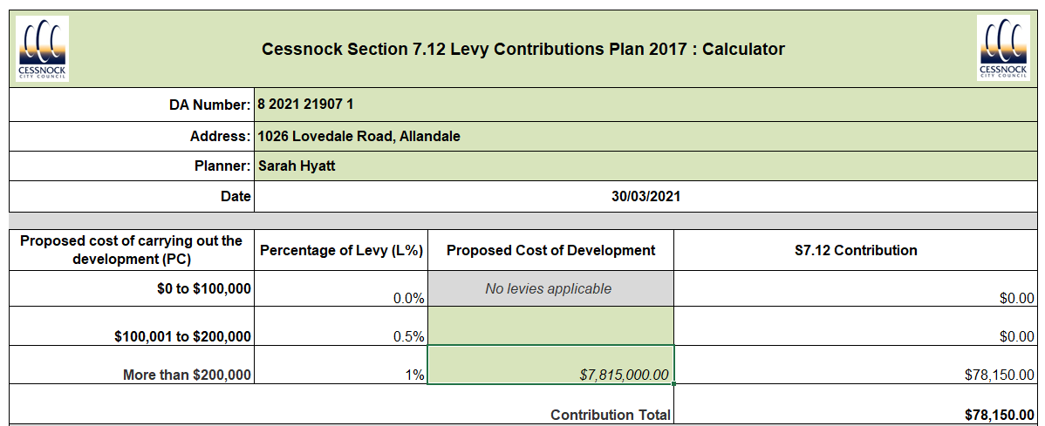

INTERNAL REFERRALS

The Development Application was referred to the following Council officers for comment:

Officer | Comment
Development Engineer | The site is affected by flooding in the 1% AEP event from a 2nd order watercourse which flows north to south. The proposed storage shed to store batteries is well above the FPL. In order to achieve flood free access, installation of 1800 x 1800 box culverts are required.  The surface under the solar panels is to remain natural ground. Any rainfall on the solar panels will drain onto the surface and flow to the natural catchment. The only increased impervious area is from concrete plinth and shade awning above the inverters and platform for the transformers as well as the storage shed. These flows are not expected to be of large scale compared to the size of development and site. It is not expected to have a significant effect on site drainage or any impact on adjoining properties.  The SoEE indicates that the majority of vehicles will access the site during the construction and operational phases. Other than at those times, the site will generally be unoccupied and contractors will only come to the site to conduct maintenance. It is indicated that no more than six contractors are anticipated to be on site during operation at any one time and that there is no expectation of the need for any ongoing visits by large vehicles. The subject development is not expected to generate traffic that will require road/intersection upgrades.  The proposed development is satisfactory from an engineering perspective.
Ecologist | The Biodiversity Offset Scheme (BOS) has been triggered, as the proposed development exceeds the clearing threshold of 1 ha, based on a minimum lot size of 40 ha.  One Plant Type Community (PCT) was found to occur within the proposed development footprint; PCT 1601 – Spotted Gum – Narrow-leaved Ironbark – Red Ironbark Shrub – Grass Open Forest of the Central and Lower Hunter Derived Native Grassland. Four individual specimens of the critically endangered flora species, Slaty Red Gum (Eucalyptus glaucina), were recorded outside of the development footprint.  The development footprint and internal access road have been located in areas of the lot where the potential ecological impact is considered low. The development is supported from an ecology perspective.
Heritage Advisor | The subject site is not identified as an item of heritage significance, but is directly opposite the Greta Migrant Camp site, which is an item of local heritage significance.  The proposed solar farm is situated a considerable distance from the site boundaries and from Lovedale Road, whereby the proposed works are not likely to result in any visual impacts on the setting or curtilage of the heritage item.  An AHIMS search has revealed a number of identified Aboriginal sites in the vicinity of the site, but none that have been identified or recorded within the subject site itself.  The proposed development is supported from a heritage perspective.

EXTERNAL REFERRALS

The Development Application was referred to the following external agencies for comment:

Agency | Comment or concurrence? | Outcome
TfNSW (RMS) | Comment | No objection raised, comments provided.
Ausgrid | Comment | No objection raised, recommended conditions provided.

CONCLUSION

The Development Application has been assessed in accordance with Section 4.15(1) of the Environmental Planning and Assessment Act 1979, and all other relevant instruments and policies. As outlined in the report, the assessment has taken into consideration the relevant planning provisions and the proposal is supported based on the following:

- There are no matters within a SEPP that restrict the granting of development consent to the proposed development;
- The proposed development is consistent with the CLEP 2011. In particular, it is considered that the proposal is permissible on the land and is consistent with the objectives of the zone;
- Council officers have assessed the proposal against the requirements of the CDCP 2010 and determined that it is consistent with the prescriptive provisions;
- The objections received during the public notification period have been considered pursuant to Section 4.15(1)(d), and the matters raised are not considered sufficient to warrant refusal of the application; and
- Overall, the application is considered to be in the wider public interest.

It is therefore recommended that the application be approved subject to the conditions contained at the end of this report.

ENCLOSURES

Appendix A – Development plans

Appendix B – Advice from Transport for NSW

Appendix C – Advice from Ausgrid

Schedule 1

DEFERRED COMMENCEMNET

- The following deferred commencement condition/s must be complied with to the satisfaction of Council within 12 months from the date of this determination notice in order to obtain an operational Development Consent.
a) General Terms of approval shall be obtained from the Natural Resource Access
Regulator for works proposed within the watercourse.
The following conditions of consent, including any other conditions that may arise from resolution of matters listed in the above condition, will be included in an operational Development Consent.
The consent shall become operational once Council has notified the applicant in writing that the information submitted in response to the deferred commencement condition/s, is/are acceptable

CONDITIONS OF CONSENT

- Approved Plans and Documents

Development must be carried out strictly in accordance with DA No. 8/2021/21907/1 and the following plans and supplementary documentation, except where amended by the conditions of this consent.

Plan Reference | Drawn By | Dated
Array Layout, Drawing No. ADL-SF-0001, Revision D | Cameron Dinkha | 07/03/2021
Overall Site Layout, Drawing No. ADL-SF-0002, Revision C | Cameron Dinkha | 07/03/2021
Site Landscape Layout, Drawing No. ADL-SF-0003, Revision D | Cameron Dinkha | 07/03/2021
DC Block Design, Drawing No. ADL-SF-0004, Revision B | Robert Frost | 13/02/2022
PEG South Elevation, Drawing No. ADL-SF-0005, Revision B | Robert Frost | 06/02/2022
Security Fence Elevation, Drawing No. ADL-SF-0006, Revision A | Robert Frost | 21/02/2022
Site Plan (Awning) | Stratco | 27/021/2022
Current View (Awning) | Stratco | 27/01/2022
Site Plan (Shed) | Stratco | 26/10/2021
Elevations (Shed) | Statco | 26/10/2021

Document Title | Prepared By | Dated
Statement of Environmental Effects, Revision 1 | Robert Frost | 15/09/2021
Bushfire Risk Assessment Report, Revision 2 | Umwelt | 16/08/2020
Decommissioning and Site Rehabilitation Plan, Revision A | HDB | March 2022

In the event of any inconsistency between the approved plans and supplementary documentation, the plans will prevail.

- CC, PC & Notice Required

In accordance with the provisions of Section 6.6 and 6.7 (cf previous Section 81A) of the EP&A Act 1979 construction works approved by this consent must not commence until:

a) A CC has been issued by a Certifier (being Council or a registered certifier); and
b) A PC has been appointed by the person having benefit of the development consent; and
c) If Council is not the PC, notify Council no later than two (2) days before building work commences as to who is the appointed PC; and
d) At least two (2) days before commencement of building work, the person having benefit of the development consent is to notify Council as to the intention to commence building work

- BCA Compliance

Pursuant to Section 4.17(11) (cf previous s 80A) of the EP&A Act 1979 all building work must be carried out in accordance with the requirements of the BCA.

- Requirements of Electricity Supply Authority

The applicant must comply with the requirements specified by the Electricity Supply Authority, Ausgrid, as detailed within their correspondence dated 13 October 2021, Reference TRIM 2017/12/285, a copy of which is attached to this consent.

PRIOR TO THE ISSUE OF A CONSTRUCTION CERTIFICATE

The following conditions are to be complied with, to the satisfaction of the Certifier, prior to issue of a Construction Certificate.

- Long Service Levy

In accordance with Section 34 of the Building and Construction Industry Long Service Payments Act 1986, the applicant must pay a long service levy at the prescribed rate to either the Long Service Payments Corporation or Council for any work costing $25,000 or more. The Long Service Levy is payable prior to the issue of a CC.

- Cessnock Section 7.12 Levy Development Contributions Plans (2020)

A total monetary contribution of $78,150.00 is to be paid to Council, pursuant to Section 7.12 of the EP&A Act 1979, such contribution is to be paid prior to the issue of any CC.

i) This condition is imposed in accordance with the provisions of Cessnock Section 7.12 Levy Contributions Plan 2017 (as amended). A copy of the document is available on Council’s website at www.cessnock.nsw.gov.au or may be inspected at Councils’ Customer Services Section, Administration Building, Vincent Street Cessnock.
ii) The amount of contribution payable under this condition has been calculated at the date of consent. In accordance with the provisions of the Contributions Plan, this amount shall be indexed at time of actual payment in accordance with the Consumer Price Index. Indexation of contributions for payment occurs quarterly.

Any party intending to act on this consent should contact Council prior to the date of payment to determine the indexed amount payable.

- Car Parking – Commercial/Industrial

The design of the vehicular access and off street parking facilities must comply with, but not be limited to AS 2890.1-2004 Parking Facilities – Off-Street Car Parking, AS 2890.2-2002 Parking Facilities – Off-Street commercial vehicles facilities, and AS 2890.3-1993 Parking Facilities – Bicycle parking facilities. Details demonstrating compliance with these Standards are to be included on the plans submitted in association with a CC application.
A design certificate satisfying these requirements is to be issued by a suitably qualified professional engineer and submitted to the Certifier prior to the issue of a CC.

- Stormwater – Discharge (General)

The applicant shall collect all roof and stormwater runoff from the impervious areas on site, and any other drainage entering the site, and discharge it to Council's satisfaction in accordance with Council's ‘Engineering Requirements for Development’.
The plans submitted in association with the CC application are to demonstrate compliance with this requirement. The plans are be approved by the Certifier as satisfying this requirement prior to the issue of the CC.

- Dilapidation Report – Council Property

A dilapidation report on the visible and structural condition of the following public infrastructure must be provided to Council prior to the issue of a CC:
a) Lovedale Road pavement & shoulders along the site frontage
The dilapidation report is to be prepared by a practising Structural / Civil Engineer agreed to by both the applicant and Council. All costs incurred in achieving compliance with this condition shall be borne by the applicant.
The liability of any damage to public infrastructure in the vicinity of the site, where such damage is not accurately recorded by the requirements of this condition, will be borne by the applicant

- Access Road

The registered proprietors shall provide details of an all-weather access road from the property boundary to the proposed development. The access road will need to be constructed to 4m wide, 100mm thick pavement with 1m wide clear verges either side and incorporate a culvert crossing in accordance with hdb drawing Ref.21038 dated 10/03/2022. All works are to be in accordance with Council’s ‘Engineering Requirements for Development’ and NSW Rural Fire Service ‘Planning for Bushfire Protection’ to serve the proposed development.

The plans submitted in association with the CC application are to demonstrate compliance with this requirement. The plans are to be approved by the Certifier as satisfying this requirement prior to the issue of a CC.

- Detailed Landscape Plan

A detailed Landscape Plan prepared by a suitably qualified person must be submitted and approved, prior to the issue of a CC. The plan must include:
a) Location of all proposed and existing planting, delineating existing trees to be retained, removed or transplanted
b) A detailed planting schedule including species by botanical and common names, quantities,
pot sizes and estimated size at maturity
c) Details of planting procedure
d) Details of earthworks including mounding, retaining walls and planter boxes
e) A landscape maintenance schedule for the owner/occupier to administer over the
determined time frame
f) Details of drainage and watering systems including detailed specification and plans
including; proposed material, make/model, dimensions, quantities
g) The landscaping of the site is to be designed to:
i) Be low maintenance with native species characteristic of the Lower Hunter Spotted
Gum – Ironbark Forest EEC
ii) Be designed for a safe level of transparency
iii) Include significant canopy trees where possible
iv) Include trees and shrubs known to be fauna food sources where possible
v) Provide perimeter planting adjacent to the car park
vi) Not interfere with sight lines for vehicles entering or exiting the site (at full height-
post establishment)

PRIOR TO COMMENCEMENT OF WORKS

The following conditions are to be complied with prior to the commencement of works on the subject site

- Construction and Traffic Management Plan

The applicant must prepare a Construction Management and Traffic Management Plan incorporating the following matters. The plan must be submitted to and approved by the PC as satisfying these matters prior to the commencement of works.

a) A plan view of the entire site and frontage roadways indicating:
i) Dedicated construction site entrances and exits, controlled by a certified traffic controller, to safely manage pedestrians and construction related vehicles in the frontage roadways.
ii) Turning areas within the site for construction and spoil removal vehicles, allowing a forward egress for all construction vehicles on the site.
iii) The locations of proposed work zones in the frontage roadways.
iv) Location of any proposed crane, concrete pump, truck standing areas on and off the site.
v) A dedicated unloading and loading point within the site for all construction vehicles, plant and deliveries.
vi) Material, plant and spoil bin storage areas within the site, where all materials are to be dropped off and collected.
vii) An onsite parking area for employees, tradespersons and construction vehicles as far as possible.
viii) The proposed areas within the site to be used for the storage of excavated material, construction materials and waste and recycling containers during the construction period.
ix) How it is proposed to ensure that soil/excavated material is not transported onto surrounding footpaths and roadways.
x) The proposed method of support to any excavation adjacent to adjoining properties, or the road reserve. The proposed method of support is to be designed by a Chartered Civil Engineer.
b) During excavation, demolition and construction phases, noise generated from the site must be controlled.
c) All site works must comply with the work health and safety requirements of SafeWord NSW.
d) During excavation, demolition and construction phases, toilet facilities are to be provided on site, at the rate of one (1) toilet for every twenty (20) persons or part of twenty (20) persons employed at the site.
e) All traffic control plans must be in accordance with the TfNSW publication Traffic Control Worksite Manual and prepared by a suitably qualified person (minimum ‘red card’ qualification). The main stages of the development requiring specific construction management measures are to be identified and specific traffic control measures identified for each stage.

Approval is to be obtained from Council for any temporary road closures or crane use from public property. Applications to Council shall be made a minimum of six (6) weeks prior to the proposed activity being undertaken.

- PC Signage and Contact Details

Prior to the commencement of works, a sign must be erected in a prominent position on the site on which the proposal is being carried out. The sign must state:
a) Unauthorised entry to the work site is prohibited
b) The name of the principal contractor (or person in charge of the site) and a telephone
number on which that person may be contacted at any time for business purposes and
including outside working hours
c) The name, address and telephone number of the PC for the work
Any such sign must be maintained while the work is being carried out, but must be removed when the work has been completed.

- Public Liability Insurance

Any person or contractor undertaking works on public property must take out Public Risk insurance with a minimum cover of twenty (20) million dollars in relation to the occupation of, and approved works within, public property. The Policy is to note, and provide protection for Cessnock City Council as an interested party, and a copy of the Policy must be submitted to Council prior to commencement of the works. The Policy must be valid for the entire period that the works are being undertaken on public property. The insurance shall also note the location and the risk.

- S.138 Roads Act 1993 Approvals

Under Section 138 of the Roads Act 1993, should any work on the verge, footpath, or public road reserve be required, a S138 Roads Act Approval will need to be obtained from Council. In this regard, the applicant is to make a formal application to Council. The S138 application is to be submitted to, and approved by, Council prior to works commencing.

- Relocation of Services

The registered proprietor of the land shall be responsible for all costs incurred in the necessary relocation of any services affected by the required construction works. Council and other service authorities should be contacted for specific requirements prior to commencement of any works.

- Trees to be Retained

Any trees to be retained within (10 m of) the development footprint must be fenced prior to construction works beginning. The fencing is to encompass the maximum possible area within the drip line of the canopy. Tree protection signage must be attached to the fencing surrounding the retained trees.

DURING WORKS

The following conditions are to be complied with during works:

- Construction Hours

Excavation, building or subdivision work must be restricted to the hours of 7.00am and 5.00pm on Monday to Saturday inclusive. Work is not to be carried out on Sundays and public holidays.

- Site is Securely Fenced

The site must be appropriately secured and fenced at all times during works.

- Approved Plan Kept On Site

A copy of the approved plans must be kept on site for the duration of site works and be made available upon request.

- Construction Noise

Noise arising from the works must be controlled in accordance with the requirements of the Protection of the Environment Operations Act 1997 and guidelines contained in the New South Wales Environment and Heritage Noise Guide for Local Government.

- Location of Council Pipes

During all phases of demolition, excavation and construction, it is the full responsibility of the applicant and their contractors to:
a) Ascertain the exact location of the Council stormwater drainage pipeline and associated pits traversing the site in the vicinity of the works
b) Take measures to protect the in-ground Council stormwater drainage pipeline and
associated pits
c) Ensure dedicated overland flow paths are satisfactorily maintained through the site
Stormwater drainage pipes can be damaged through applying excessive loading (such as construction machinery, material storage, and the like). All proposed structures and construction activities must be sited fully clear of Council’s stormwater drainage pipes, pits, easements, watercourses and overland flow paths on the site
If the Council pipeline is uncovered during construction, all work must cease, and the PC and Council must be contacted immediately for advice. Any damage caused to the Council stormwater drainage system must be immediately repaired in full as directed, and at no cost to Council.

- Erosion and Sediment Control

The control of erosion, and the prevention of silt discharge into drainage systems and waterways, will be necessary in accordance with Council’s “Engineering Requirements for Development”, and Landcom’s Soils and Construction Manual - April 2004. Erosion control measures are to be implemented prior to the commencement of any earthworks, and shall be maintained until satisfactory completion and restoration of site earthworks, including revegetation of all exposed areas.

- Stormwater Runoff

Alterations to the natural surface contours must not impede or divert natural surface water runoff, so as to cause a nuisance to adjoining property owners.

- Tree Protection

Stockpiling or storage or mixing of materials (including soil), vehicle parking, disposal of liquids, machinery repairs, refuelling and the siting of any new offices or sheds must not occur within the drip line of retained trees during any stage of the development.

- Clearing of Development Footprint

During construction works all vehicles must be washed before entering the site to prevent the spread of exotic species.

- Tree Protection Fencing

All tree protection fencing and signage as required by Condition 17 must remain in place until completion of construction works.

- Clearing to be Carried Out

Clearing of native vegetation and development activities must only occur within the approved development footprint as shown in Figure 1.2 (Development Footprint) of the Biodiversity Development Assessment Report by Umwelt (Australia) Pty Ltd dated September 2021.

- Bushfire Protection

The following bush fire protection measures are to be implemented at the commencement of building works, and maintained for the life of the development:

- Asset Protection Zones

The intent of measures is to minimise the risk of bush fire attack and provide protection for emergency services personnel, residents and others assisting fir-fighting activities. To achieve this, the following conditions shall apply:

At the commencement of building works, and in perpetuity, the 10m APZ around the development shall be managed as an ‘Inner Protection Area’ in accordance with Appendix 4 of Planning for Bush Fire Protection 2019 and the NSW Rural Fire Service’s document Standards for Asset Protection Zones.

- Water and Utilities

The intent of measures is to minimise the risk of bush fire attack and provide protection for emergency services personnel, residents and others assisting fire-fighting activities. To achieve this, the following conditions shall apply:

- The provision of water, electricity and gas shall comply with Table 7.4a of Planning for Bush Fire Protection 2019.
- A 22,500 litre water supply tank (manufactured from concrete or metal) shall be provided for fire-fighting purposes. A Rural Fire Service standard 65mm metal Storz outlet with a ball valve shall be fitted to the outlet within the ‘Inner Protection Area’ or the non-hazard side away from the structure.
- A minimum 5hp or 3kW petrol or diesel-powered pump shall be provided for connection to the water supply and shielded against bush fire attack. A hose of minimum 19mm internal diameter with reel for fire-fighting shall be provided for connection to the pump.

- Access

The intent of measures is to provide safe operational access on property access roads for emergency services personnel in supressing a bush fire, and for occupants faced with evacuation. To achieve this, the following conditions shall apply:

Access shall comply with Table 7.4a of Planning for Bush Fire Protection 2019.

PRIOR TO THE ISSUE OF AN OCCUPATION CERTIFICATE

The following conditions are to be complied with, to the satisfaction of the Principal Certifier, prior to issue of an Occupation Certificate (as specified within the condition):

- Roads – Bitumen Crossing

The registered proprietors shall construct and maintain a bitumen sealed access crossing from the edge of the road formation in Lovedale Road to the property boundary, in accordance with Council’s “Engineering Requirements for Development” and AS 2890.1. A S138 Roads Act Approval is required from Council prior to any construction commencing within the road reserve. The access crossing is required to be constructed prior to the issue of an OC.

Construction of the crossing will require inspections to be undertaken by Council. The applicant shall pay Council engineering site supervision fees in accordance with Council’s current Fees & Charges, prior to the inspections being undertaken.

The initial fee will facilitate approval of the application and one (1) construction inspection (gravel in place but prior to sealing of the crossing).

A final inspection will be required upon completion of the driveway and restoration of all disturbed footway areas. (A separate fee will be required to be paid when the final inspection is booked.). Should further inspections become necessary as a result of unsatisfactory or defective works, additional inspection fees will be charged in accordance with Council’s current Fees & Charges.

The applicant is to advise Council at least 48 hours prior to inspection of works within the footpath and/or road reserve

- Roads – Access Completion

The access road to serve the subdivision shall be completed in accordance with Council’s ‘Engineering Requirements for Development’ prior to the issue of an OC.

- Drainage Works

All drainage works required to be undertaken in accordance with this consent shall be completed prior to issue of an OC for the development.

- Flood Mitigation Works

All flood mitigation works required to be undertaken in accordance with this consent shall be completed prior to issue of an OC for the development.

- Completion of Landscape Works

All landscape works, including the removal of all noxious weed species, are to be undertaken in accordance with the approved landscape plan and conditions of Development Consent, prior to the issue of an OC.

- Parking – Completion

Car parking areas shall be completed prior to the issue of an OC.

- Fencing

All proposed fencing must be completed prior to the issue of an OC.

- Second Dilapidation Report

A second Dilapidation Report, including a photographic survey, must be submitted after the completion of works. A copy must be lodged with Council and the PC prior to the issue of an OC.

- Completion of Landscape Works

All landscape works, including the removal of all noxious weed species, are to be undertaken in accordance with the approved landscape plan and conditions of Development Consent, prior to the issue of an OC.

- Bushfire Protection

The Bushfire Protection Measures and standards as outlined within Condition 29 (which forms part of this consent), shall be installed/completed prior to issue of an OC.

- Finish of Excavated &/or Filled Areas Around Site

The excavated and/or filled areas of the site are to be stabilised and drained, to prevent scouring onto adjacent private or public property. The finished ground around the perimeter of the building is to be graded to prevent ponding of water, and to ensure the free flow of water away from the building and adjoining properties.

ONGOING USE

The following conditions are to be complied with as part of the ongoing use of the premises:

- Driveways to be Maintained

All access crossings and driveways shall be maintained in good order for the life of the development.

- Road – Advice

The applicant is advised that Council will not accept responsibility for the road access. In this respect, the care, control and maintenance thereof, is the sole responsibility of the user/s, in perpetuity.

- Weeds

The weed, Fireweed (Senecio madagascariensis) on the site must be removed.

- Maintenance of Native Vegetation

All native vegetation on the site outside of the approved development footprint, as shown in Figure 1.2 (Development Footprint) of the Biodiversity Development Assessment Report by Umwelt (Australia) Pty Ltd dated September 2021, must be retained in a natural state and not grazed, cleared, picked (as defined in the Biodiversity Conservation Act 2016) or disturbed in any way.

- Outdoor Lighting

All outdoor lighting must not detrimentally impact upon the amenity of other premises and adjacent dwellings and road reserve, and must comply with, where relevant, AS 1158.3:2005 Lighting for roads and public spaces – Pedestrian Area (Category P) lighting – Performance and design requirements and AS 4282:1997 Control of the obtrusive effects of outdoor lighting.

- Maintenance of Landscaping

Landscaping shall be maintained in accordance with the approved plan in a healthy state, and in perpetuity, by the existing or future owners and occupiers of the development. If any of the vegetation comprising the landscaping dies or is removed, it is to be replaced with vegetation of the same species and similar maturity as the vegetation which has died or was removed.

- Decommissioning and Rehabilitation

Should the use of the solar farm cease, all panels and infrastructure associated with the solar farm shall be removed and decommissioned within twelve (12) months of cessation of the use.

All works shall be undertaken in accordance with the Decommissioning and Rehabilitation Plan, prepared by HDB, dated 10.03.2022.Suitable evidence of compliance with the above requirement, must be provided to Council upon completion of the decommissioning and rehabilitation works.

In the event the solar farm is decommissioned, a Dilapidation Report in respect of the visible and structural condition of Lovedale Road (from the point of access to the site to the entrance ramp onto the Hunter Expressway west and 500m along Lovedale Road to the north), is required to be submitted to, and approved by Council.

The Dilapidation Report must include a photographic survey, and be prepared by a practising structural/civil engineer agreed to by both the applicant and Council. Any damage to Wills Hill Road caused during decommissioning of the solar farm will require rectification, at the applicant’s cost. Any such works will require approval under Section 138 of the Roads Act 1993, and must be carried out in conjunction with the decommissioning and rehabilitation works

ADVICE

- “DIAL BEFORE YOU DIG” DIAL 1100

Before any excavation work starts, contractors and others should phone the “Dial Before You Dig” service to access plans/information for underground pipes and cables. www.dialbeforeyoudig.com.au

- Aboriginal Heritage

As required by the National Parks and Wildlife Act 1974 and the Heritage Act 1977, in the event that Aboriginal cultural heritage or historical cultural fabric or deposits are encountered/discovered where they are not expected, works must cease immediately and Council and Heritage NSW must be notified of the discovery.

In the event that archaeological resources are encountered, further archaeological work may be required before works can re-commence, including the statutory requirement under the Heritage Act 1977 to obtain the necessary approvals/permits from Heritage NSW.

Note: The National Parks and Wildlife Act 1974 and the Heritage Act 1977 impose substantial penalty infringements and/or imprisonment for the unauthorised destruction of archaeological resources, regardless of whether or not such archaeological resources are known to exist on the site. Should any item required to be harmed an Aboriginal heritage impact Permit will be required before any further works are undertaken.

- Responsibility for Other Consents/Agreements

The applicant is solely responsible for ensuring that all additional consents and agreements are obtained from other authorities, as relevant.

